





“*Here are my mother and my brothers!*

*Whoever does the will of God is my brother and sister and mother*.”

The Second Sunday after Pentecost

**The Holy Eucharist**Christ Church Episcopal

Reading, Pennsylvania

June 6, 2021

Services at **8:00 am** (spoken) and **10:15 am** (with music)

_Prelude: *(A time for quiet reflection)*

**Organ Prelude**:  Prelude on two Folk Hymns *Lee Hastings Bristol Jr.*

Resignation (664 *The Hymnal 1982*)

Slane (488 The *Hymnal 1982*)

**Processional Hymn** **47**  *Gott sei Dank*

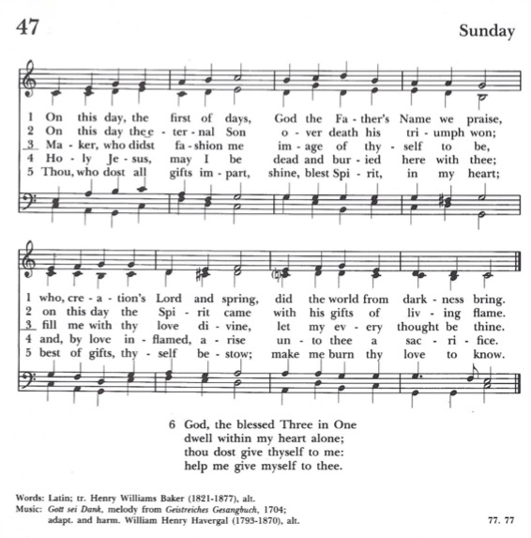

*Celebrant:* Alleluia. Christ is risen.

*People:* ***The Lord is risen indeed. Alleluia***

*Everyone:* ***Almighty God, to you all hearts are open, all desires known, and from you no secrets are hid: Cleanse the thoughts of our hearts by the inspiration of your Holy Spirit, that we may perfectly love you, and worthily magnify your holy Name; through Christ our Lord***. ***Amen****.*

**Glory to God**:(*Spoken only at 8:00 am*; *BCP Page 356*)*Gloria in excelsis*

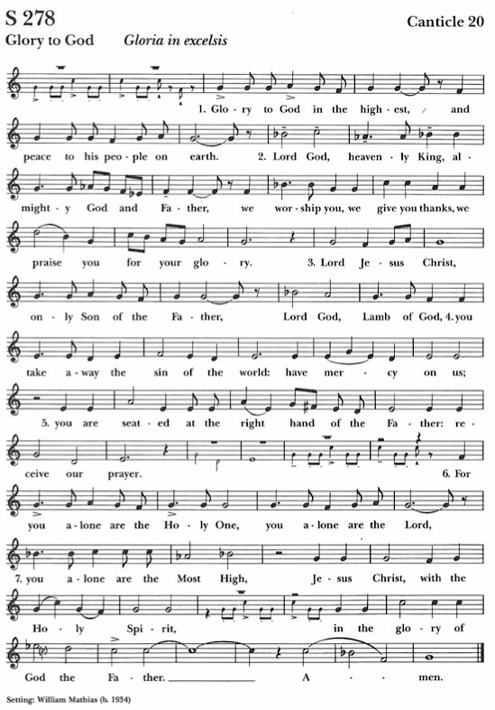

**The Collect of the Day** *Page 225 BCP* *Celebrant;* The Lord be with you.  
*People*: ***And also with you.****Celebrant* : Let us pray.

O God, from whom all good proceeds: Grant that by your inspiration we may think those things that are right, and by your merciful guiding may do them; through Jesus Christ our Lord, who lives and reigns with you and the Holy Spirit, one God, for ever and ever.  ***Amen****.*

**The Old Testament** *(Please be seated):**Genesis 3:8-15*

A Reading from The Book of Genesis

They heard the sound of the Lord God walking in the garden at the time of the evening breeze, and the man and his wife hid themselves from the presence of the Lord God among the trees of the garden. But the Lord God called to the man, and said to him, “*Where are you*?” He said, “*I heard the sound of you in the garden, and I was afraid, because I was naked; and I hid myself*.” He said, “*Who told you that you were naked? Have you eaten from the tree of which I commanded you not to eat*?” The man said, “*The woman whom you gave to be with me, she gave me fruit from the tree, and I ate.*” Then the Lord God said to the woman, “*What is this that you have done*?” The woman said, “*The serpent tricked me, and I ate*.” The Lord God said to the serpent,

“*Because you have done this,  
cursed are you among all animals   
and among all wild creatures;*

*upon your belly you shall go,  
and dust you shall eat   
all the days of your life.*

*I will put enmity between you and the woman,  
and between your offspring and hers;*

*he will strike your head,  
and you will strike his heel*.”

The Word of the Lord *People:* ***Thanks be to God****.*

**The Psalm**:

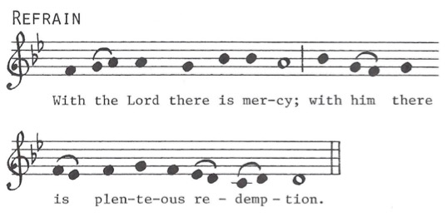

**Psalm 130:** *Read responsively by half-verse at 8:00 service only* *De profundis*

1 Out of the depths have I called to you, O Lord; Lord, hear my voice; *  
*let your ears consider well the voice of my supplication*. REFRAIN

2 If you, Lord, were to note what is done amiss, *  
 *O Lord, who could stand*?

3 For there is forgiveness with you; *  
*therefore you shall be feared*. REFRAIN

4 I wait for the Lord; my soul waits for him; *  
*in his word is my hope*.

5 My soul waits for the Lord, more than watchmen for the morning, *  
*more than watchmen for the morning*. REFRAIN

6 O Israel, wait for the Lord, *  
*for with the Lord there is mercy*;

7 With him there is plenteous redemption, *  
*and he shall redeem Israel from all their sins*. REFRAIN

**The Epistle** *(Please remain seated):**2 Corinthians 4:13-5:1*

A Reading from The Second Letter to the Corinthians:

Just as we have the same spirit of faith that is in accordance with scripture—“*I believed, and so I spoke*” —we also believe, and so we speak, because we know that the one who raised the Lord Jesus will raise us also with Jesus, and will bring us with you into his presence. Yes, everything is for your sake, so that grace, as it extends to more and more people, may increase thanksgiving, to the glory of God.

So, we do not lose heart. Even though our outer nature is wasting away, our inner nature is being renewed day by day. For this slight momentary affliction is preparing us for an eternal weight of glory beyond all measure, because we look not at what can be seen but at what cannot be seen; for what can be seen is temporary, but what cannot be seen is eternal.

For we know that if the earthly tent we live in is destroyed, we have a building from God, a house not made with hands, eternal in the heavens.

The Word of the Lord. *People:* ***Thanks be to God****.*

**Gospel Anthem:** Ye Servants of God *Henry Coleman*

*Ye servants of God, your Master proclaim,*

*And publish abroad His wonderful Name:*

*The Name all victorious of Jesus extol:*

*His Kingdom is glorious and rules over all.*

*Salvation to God who sits on the throne!*

*Let all cry aloud and honor the Son.*

*The praises of Jesus the angels proclaim,*

*Fall down on their faces, and worship the Lamb.*

*Then let us adore, and give Him His right,*

*All glory and power, al wisdom and might.*

*All honor and blessing with angels above,*

*And thanks never ceasing, and infinite love.*

**The Gospel**

*All please* ***stand*** *as the Celebrant reads the Gospel, first saying: Mark 3:20-35*

The Holy Gospel of our Lord Jesus Christ, according to Mark:

*People:* ***Glory to you, Lord Christ***

The crowd came together again, so that Jesus and his disciples could not even eat. When his family heard it, they went out to restrain him, for people were saying, “*He has gone out of his mind.*” And the scribes who came down from Jerusalem said, “*He has Beelzebul, and by the ruler of the demons he casts out demons*.” And he called them to him, and spoke to them in parables, “*How can Satan cast out Satan? If a kingdom is divided against itself, that kingdom cannot stand. And if a house is divided against itself, that house will not be able to stand. And if Satan has risen up against himself and is divided, he cannot stand, but his end has come. But no one can enter a strong man’s house and plunder his property without first tying up the strong man; then indeed the house can be plundered*.

“*Truly I tell you, people will be forgiven for their sins and whatever blasphemies they utter; but whoever blasphemes against the Holy Spirit can never have forgiveness, but is guilty of an eternal sin*”— for they had said, “*He has an unclean spirit*.”

Then his mother and his brothers came; and standing outside, they sent to him and called him. A crowd was sitting around him; and they said to him, “*Your mother and your brothers and sisters are outside, asking for you.*” And he replied, “*Who are my mother and my brothers*?” And looking at those who sat around him, he said, “*Here are my mother and my brothers! Whoever does the will of God is my brother and sister and mother*.”

*Celebrant:* The Gospel of the Lord.

*People*: ***Praise to you, Lord Christ****.*

**The Sermon** *The Rev. Canon John Francis*

**The Nicene Creed** (*Said by* ***all****. Please* ***stand*** *as able*.)

**We believe in one God, the Father, the Almighty,**

**maker of heaven and earth, of all that is, seen and unseen.  
We believe in one Lord, Jesus Christ, the only Son of God,  
eternally begotten of the Father,**

**God from God, Light from Light, true God from true God,  
begotten, not made, of one Being with the Father.  
Through him all things were made.**

**For us, and for our salvation, he came down from heaven:  
by the power of the Holy Spirit, he became incarnate from the Virgin Mary,  
and was made man.   
For our sake, he was crucified under Pontius Pilate;  
he suffered death and was buried.  
On the third day, he rose again in accordance with the Scriptures;  
he ascended into heaven and is seated at the right hand of the Father.**

**He will come again in glory to judge the living and the dead,  
and his kingdom will have no end.**

**We believe in the Holy Spirit, the Lord, the giver of life,   
who proceeds from the Father and the Son.  
With the Father and the Son, he is worshiped and glorified.  
He has spoken through the Prophets.**

**We believe in one holy catholic and apostolic Church.  
We acknowledge one baptism for the forgiveness of sins.**

**We look for the resurrection of the dead,  
and the life of the world to come. *Amen****.*

**The Prayers of the People** *(Please remain standing or kneel)*

*Celebrant or Deacon:*

The Spirit of God aids us in our weakness and empowers to pray. In the love of the Spirit, let us offer prayers to God for the needs, concerns, and hopes of all the world.

*Deacon or Leader*: For peace from on high and for our salvation.

Lord, hear us.

*People:* ***Lord, graciously hear us.***

*Leader*: For this parish family of Christ Church, Reading, that we will faithfully bear witness to the risen Christ in word and deed.

Lord, hear us.

*People:* ***Lord, graciously hear us.***

*Leader*: For the justice and peace of the whole world, for the welfare of the holy churches of God, and for the unity of all.

Lord, hear us.

*People:* ***Lord, graciously hear us.***

*Leader*: For this holy gathering and for those who enter with faith, reverence, and love of God.

Lord, hear us.

*People:* ***Lord, graciously hear us.***

*Leader*: For the newly baptized illumined by the light of Christ.

Lord, hear us.

*People:* ***Lord, graciously hear us.***

*Leader*: For Michael, our presiding bishop, Kevin, our bishop, John, our rector, Midge, our deacon, Michael, our postulant for Holy Orders, all who minister in Christ and for all the holy people of God.

Lord, hear us.

*People:* ***Lord, graciously hear us.***

*Leader*: For the world and its leaders, our nation and its people, and all who are elected to represent them in the government.

Lord, hear us.

*People:* ***Lord, graciously hear us.***

*Leader*: For all those in need, the suffering, the oppressed and the refugees, travelers and prisoners, and the dying.

Lord, hear us.

*People:* ***Lord, graciously hear us.***

*Leader*: For those who have gone before us under the sign of faith, and for all the departed, especially *William Pflum.*

Lord, hear us.

*People:* ***Lord, graciously hear us.***

*Leader*: For ourselves, our families, and those we love, especially :

*[Names may be read from the prayer list, then spoken aloud by the people].*

Lord, hear us.

*People:* ***Lord, graciously hear us.***

*Leader:* For those who celebrate birthdays and anniversaries this week, especially:

Deacon Midge Pendergast (6/6), James Wilson (6/8), Brendan Boggs (6/10),

Colleen Boggs (6/10), Maritriny Rivas (6/10), Samuel Mercado (6/11) and Marcia Laedlein (6/12).

Lord, hear us.

*People:* ***Lord, graciously hear us.***

*Leader*: Remembering Mary, the God-bearer, and all the saints, let us offer ourselves and one another to the living God through Christ.

*People:* ***To you, O Lord.***

*Celebrant:*  
Blessed are you, O Lord our God, for you transform our lives and makes us new: Hear our prayers which we offer in confidence and breathe upon us with your Holy Spirit. Glory to you for ever and ever.

*People:* ***Amen.***

**Confession of Sin**

*Celebrant* Let us confess our sins against God and our neighbor.

*Celebrant and People*:

**Most merciful God,  
we confess that we have sinned against you in thought, word, and deed,   
by what we have done, and by what we have left undone.  
We have not loved you with our whole heart; we have not loved our neighbors as ourselves.   
We are truly sorry and we humbly repent.   
For the sake of your Son Jesus Christ, have mercy on us and forgive us;  
that we may delight in your will, and walk in your ways, to the glory of your Name. *Amen***.

*The priest stands and says:*

Almighty God have mercy on you, forgive you all your sins through our Lord Jesus Christ, strengthen you in all goodness, and by the power of the Holy Spirit keep you in eternal life.  **Amen**.

**The Peace**

*All stand. The Celebrant says to the people:*

The peace of the Lord be always with you.

*People:* ***And also with you***.  
*Then the Celebrant, Ministers and People may acknowledge one another in the name of the Lord.*

**Announcements**

**Offertory Hymn:** LEVAS **188** *Philip P. Bliss*

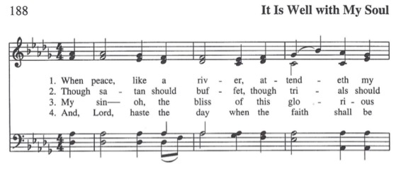

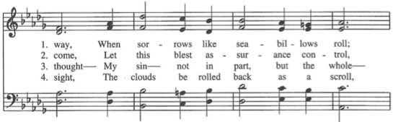

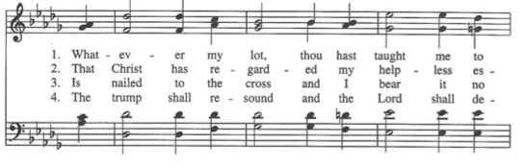

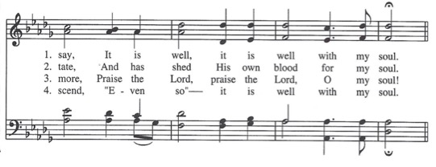

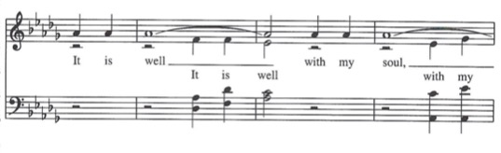

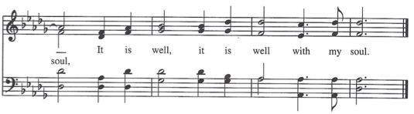

**The Holy Communion**

**Eucharistic Prayer A** *(page 361 in the Book of Common Prayer)*

*The people remain standing. The Celebrant faces them and sings or says:*

The Lord be with you.

*People*: **And also with you**.

*Celebrant:* Lift up your hearts.

*People:* **We lift them to the Lord**.

*Celebrant:* Let us give thanks to the Lord our God.

*People:* **It is right to give him thanks and praise**.

*Then, facing the Holy Table, the Celebrant proceeds:*

It is right, and a good and joyful thing, always and everywhere to give thanks to you, Father Almighty, Creator of heaven and earth.

Through Jesus Christ our Lord. In fulfillment of his true promise, the Holy Spirit came down from heaven, lighting upon the disciples, to teach them and to lead them into all truth; uniting peoples of many tongues in the confession of one faith, and giving to your Church the power to serve you as a royal priesthood, and to preach the Gospel to all nations.

Therefore, we praise you, joining our voices with Angels and Archangels, and with all the company of heaven, who for ever sing this hymn to proclaim the glory of your Name:

Holy, Holy, Holy Lord: **Hymn S 128** (*Spoken only at 8:00 am*) *Sanctus*

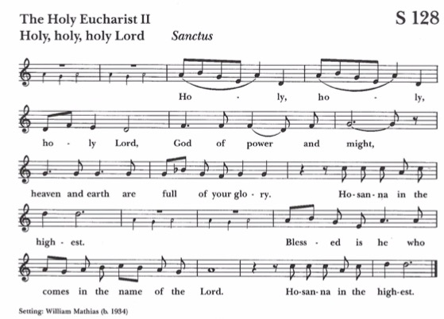

*The people* ***stand*** *or* ***kneel*** *as able. Then the Celebrant continues*:

Holy and gracious Father: In your infinite love you made us for yourself, and, when we had fallen into sin and become subject to evil and death, you, in your mercy, sent Jesus Christ, your only and eternal Son, to share our human nature, to live and die as one of us, to reconcile us to you, the God and Father of all.

He stretched out his arms upon the cross, and offered himself, in obedience to your will, a perfect sacrifice for the whole world.

*At the following words concerning the bread: The Celebrant is to hold it or to lay a hand upon it; and at the words concerning the cup: to hold or place a hand upon the cup and any other vessel containing wine to be consecrated.*

On the night he was handed over to suffering and death, our Lord Jesus Christ took bread; and when he had given thanks to you, he broke it, and gave it to his disciples, and said, "*Take, eat: This is my Body, which is given for you. Do this for the remembrance of me*."

After supper he took the cup of wine; and when he had given thanks, he gave it to them, and said, "*Drink this, all of you: This is my Blood of the new Covenant, which is shed for you and for many for the forgiveness of sins. Whenever you drink it, do this for the remembrance of me*."

Therefore, we proclaim the mystery of faith:

*Celebrant and People:****Christ has died****.* ***Christ is risen****.* ***Christ will come again*.**

We celebrate the memorial of our redemption, O Father, in this sacrifice of praise and thanksgiving. Recalling his death, resurrection, and ascension, we offer you these gifts.

Sanctify them by your Holy Spirit to be for your people the Body and Blood of your Son, the holy food and drink of new and unending life in him. Sanctify us also, that we may faithfully receive this holy Sacrament, and serve you in unity, constancy, and peace; and at the last day bring us with all your saints into the joy of your eternal kingdom.

All this we ask through your Son, Jesus Christ: By him, and with him, and in him, in the unity of the Holy Spirit all honor and glory is yours, Almighty Father, now and for ever.

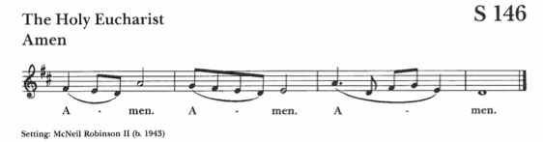

*The Celebrant sings:* As our Savior Christ has taught us, we now pray:

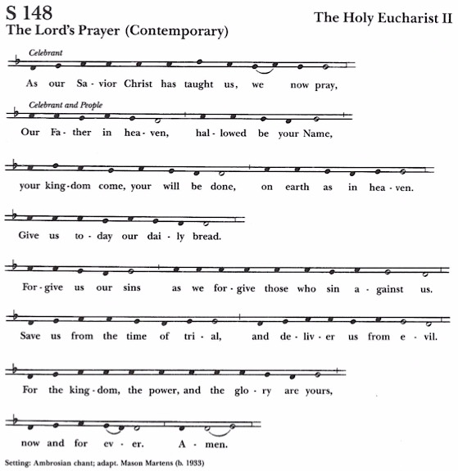

*(Spoken only at 8:00 am*)

*The Celebrant says:* And now, as our Savior, Christ, has taught us, we are bold to say:

Our Father, who art in heaven, hallowed be thy Name,   
thy kingdom come, thy will be done, on earth as in heaven.

Give us this day our daily bread.   
And forgive us our trespasses, as we forgive those who trespass against us.   
And lead us not into temptation, but deliver us from evil.

For thine is the kingdom, and the power, and the glory, for ever and ever. *Amen*.

**The Breaking of the Bread**

*The Celebrant breaks the consecrated Bread. (A period of silence may be kept.) Then may be said (8:00) or sung* ***S165****:*

Alleluia. Christ our Passover is sacrificed for us; Therefore, let us keep the feast. Alleluia.

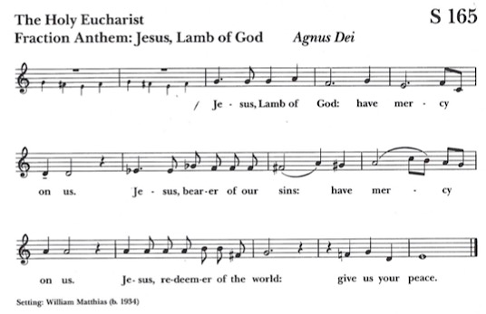

*Facing the people, the Celebrant says the following Invitation:*

The Gifts of God for the People of God. Take them in remembrance that Christ died for you, and feed on him in your hearts by faith, with thanksgiving.

(*You may request communion hosts and wine if you did not bring your own.)*

**Post Communion Prayer**

*After Communion, the Celebrant says*

Let us pray

*Celebrant and People:*

**Eternal God, heavenly Father,  
you have graciously accepted us as living members of your Son our Savior Jesus Christ,  
and you have fed us with spiritual food in the Sacrament of his Body and Blood.  
Send us now into the world in peace, and grant us strength and courage  
to love and serve you with gladness and singleness of heart: through Christ our Lord**. ***Amen***.

**Closing Hymn**:**381** *Please see Insert* *Ton-y-Botel*

**Blessing and Dismissal**:

*Celebrant:*  Go in peace to love and serve the Lord. Alleluia, alleluia!!

*Everyone* **Thanks be to God**. **Alleluia, alleluia**!!

**Organ Postlude**: All Glory Be to God On High *J.S. Bach*



**Liturgical Ministers**

**Celebrant:** TheRev. Canon John R. Francis **Organist/Choirmaster:** James K. Wilson

**Deacon**: The Rev. Dr. Midge Pendergast **Cantors:** Anita Powell,Victoria Wilson

**Lectors:** Rick Wolf (*8:00);* Anita Powell *(10:15)* **Ushers:** Walt Frankowski; Sally Wilcox *(10:15)*

**Technical video/audio**: Enrique Molina

**Altar Guild Team:** June Tull & Sophia-*Captain(s),* Kim Alarcon, Andrea Griffith; Victoria Wilson

***Virtual* *and Livestreamed* Worship Opportunities**

**Livestreamed Sunday Services on Facebook:** Holy Eucharist at 8:00 am and 10:15 am (music)

**Rise and Shine** for Young Families @ 8:45 am on Sundays

**Zoom Centering Prayer** on **Tuesdays** at 9:00 am, **Thursdays** at 8:30 am;

**Zoom Bible Study** on Wednesdays at 8 am

**Morning** **Prayer** on Thursdays at 11:30 am @ at Red Bridge Park

***You can still watch the stream without an account. Learn how to do that below:***

[*https://diobeth.org/how-to-view-facebook-livestreams-without-an-account*](https://diobeth.org/how-to-view-facebook-livestreams-without-an-account)

*For all the zoom programs (other than Rise and Shine) kindly email Fr. John to ask for an email invite:*

[*johnrfrancis@rdgchristchurch.org.*](mailto:Johnrfrancis@rdgchristchurch.org)*for any specific zoom program we offer.*

**Christ Church Office:**

**435 Court Street**

**Reading, PA 19601**

Write to us at**: P.O. Box 1094, Reading, PA 19603-1094**

**It’s easy to join our mailing list! Just send your email address by text message:**

Text **BELLS** to 42828 to get started. (*Message and data rates may apply*.)

**Regular Christ Church Office hours**: Tuesday through Thursday, 8:30 am - 2:30 PM (**610**) **374-8269**

Ext. **221** for the Office Receptionist, **Runette Gabrielle** (Tues. & Wed.) or **Kim Wagner** (Thurs.)

Ext. **221** for the Bookkeeper/Finance Manager **Robin Wunder** ([financemgr@rdgchristchurch.org](mailto:financemgr@rdgchristchurch.org))

Ext. **222** for the Rector, **Fr. John Francis** ([johnrfrancis@rdgchristchurch.org](mailto:johnrfrancis@rdgchristchurch.org)) (Facebook: Padre John Francis)

Ext. **223** for the Director of Children, Youth & Family Ministries, **Milah Allison**) ([milahallison@gmail.com](mailto:milahallison@gmail.com))

**Deacon Midge** mdpend@comcast.net

**Kim Wagner** (webmaster): officemgr@rdgchristchurch.org **Cliff Buckwalter** (Property Manager) [cabuck57@gmail.com](mailto:cabuck57@gmail.com)

**Victoria Wilson** (Bulletins) vicwil2224@gmail.com

**Michele Uhrich** (Librarian/Adult Forum Chair) [micheleandbill621@gmail.com](mailto:micheleandbill621@gmail.com)

**The Christ Church Mission**:

**Sharing God’s Love With All**

Please visit us at [www.rdgchristchurch.org](http://www.rdgchristchurch.org). The Diocesan and church staff members are listed, as well as a calendar of events. You may use this website to send in prayer requests. You may also request to be added to the list for e-blasts and newsletters.